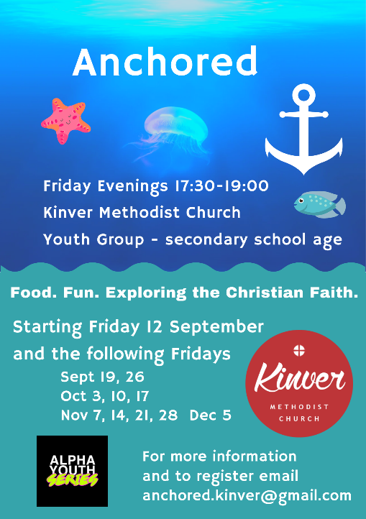**NEW YOUTH GROUP** “Anchored” Starts Friday Evening This Week 12th September at 5.30pm At Kinver Methodist Church

For Secondary school young people. There will be Food, Fun and a fantastic time 5.30pm – 7.00pm. See Flyer Attached. For more details please ring 07966 187216

**KINVER PRAISE Sunday 14 September 6.00pm** Refreshments served from 5.30pm

Service on the theme “We believe” led by Rev Andrew Sankey with Semitones

**Sunday 21st September at Kinver** at 10am we will be joined by an amazing Christian Indian lady, Janaki Menne, who has facilitated 100 church plants in Andhra Pradesh, provided for poor old people, has set up a school for poor children, with sponsorship. She visits a leper colony where the worship is vibrant, she reaches out to tribal groups and has provided relief in time of drought and flood. She will also share at the Bible study at Kingswinford on Monday 22nd September at 7.30 pm. If anyone else wants to organise for a handful of people or your family to meet with her and hear stories of work in India, on Sunday afternoon or evening, or Monday morning or afternoon – please ring or email Rev Andrew Sankey 07966 187216 apsankey@gmail.com.